**UD.09. Network Architecture and Components**

**Exercise 1**

**Given the next IP:**

**159.14.227.121/13**

**1. Which is the IP class?**

* Explanation about IPs and classes below

This is a Public Class B IP (ranges from 128. to 191., and this one es 159.)

**2. Which is its scope?**

Medium to Large sized networks.

**3. Which is its subnet mask?**

255.248.0.0

Explicación: /13 is the subnet mask. To convert it to the IP mask format, add 13 ‘1’ and the rest 0, and make groups of 8 bits and convert to decimal:

11111111.11111000.0.0

11111111 🡪 255

11111000 🡪 248

255.248.0.0

**4. How can you express that IP in binary?**

To express an IP in binary, each number needs to be converted to binary. In this case, we’ll need to convert 159, 14, 227 and 121 into binary, as an 8-bit encoded number, as follows:

159 . 14 . 227 . 121

10011111 . 00001110 . 11100011 . 01111001

**5. Which IP version is that IP?**

Version 4 (IPv4)

**Exercise 2**

**Given the next IP:**

**79.131.29.24/14**

**1. Which is its mask?**

11111111.11111100.0.0

255.252.0.0

**2. Which is the first host of the network?**

El último número corresponde al host. El primer host siempre tiene el número binario 00000001, que en decimal es 1. Se pone el 1 al final de la IP address.

79.131.**0**.**1**

**3. Which is the last host?**

El last host siempre tiene el número binario 11111110, que en decimal es 254. Este número se pone en el último lugar de la IP address.

79.131.**255.254**

**4. Which is the broadcast address?**

Para sacar la broadcast address, se ponen todos los números del host en 1, en binario.

79.131.**255**.**255**

**Exercise 3**

**Given the next IP:**

**a) fde4:0088:0000:0040:8000:0000:0000:002a**

**b) fd00::8000:0:0:c110**

**c) fd06:1200:8100:8400:2491:0000:0100:1000**

**d) fd20:202:0:1800::**

**1. Which IP version is it?**

Version 6 (IPv6)

**Is it expressed in expanded or in compressed notation?**

a) Expanded

b) Compressed

c) Expanded

d) Compressed

**Express that IP in the other notation (compressed if it’s expanded and the other way round).**

a) fde4:88:0:40:8000::2a

b) fd00:0000:0000:0000:8000:0000:0000:c110

c) fd06:1200:8100:8400:2491:0:100:1000

d) fd20:0202:0000:1800:0000:0000:0000:0000

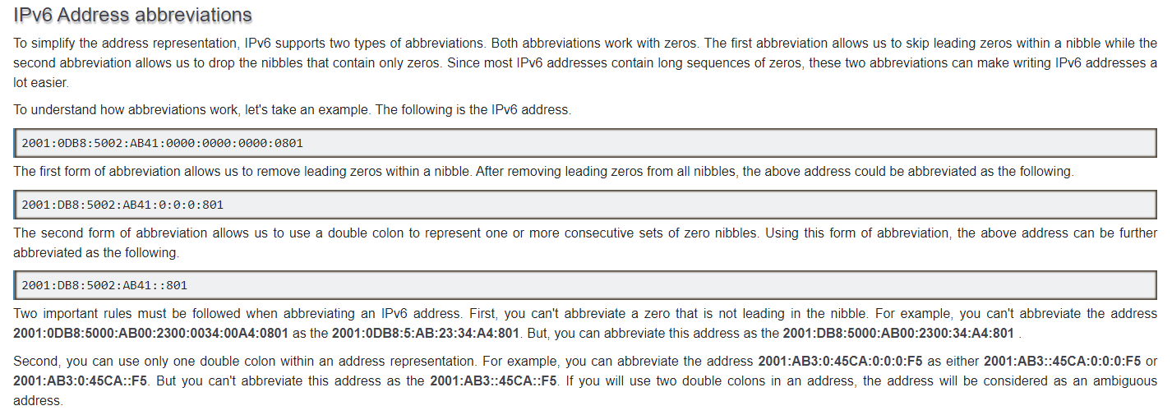

**Exercise 4**

A client approaches you to ask you for a design of a network. The client has a factory with the next requirements:

* There are 5 production line controllers that need to receive the manufacturing orders at the same time.
* There are 3 computers for the designers, that prepare the designs and send them to a computer shared among the factory network.
* There are 10 operator computers that connect to that shared computer, take the designs and send them to the production line controllers.

Think about the design of the network taking into account aspects like:

* Which topology would be the best for this case
* Whether the network would be wired, wireless, mixed...
* Which devices would you use to implement the network
* Which mask and IPs would you need to assign

The best topology would be the star topology. This topology will allow for simultaneous communication between the operator computers and the production line controllers, to receive the manufacturing orders at the same time, and will facilitate sharing information. At the same time, if a computer fails, it won’t affect the whole network.

Regarding the cable structure of the network, since it needs some reliability and stability, so the production line does not get compromised, but it also needs some flexibility for the designers and operators, I would suggest implementing a mixed network. I would use a wired network for the 5 production line controllers, to make sure the wireless connection does not fail, and also for any essential servers or computers, and a wireless network for the designers and operators’ computers.

The devices needed to implement the network would be:

* Computers: 18 computers in total (5 for the production line controllers, 3 for the designers and 10 for the operators) plus a central server to store and share designs.
* Cabling standards: for the wired connections, we could use the 568A connection. This will also include all the structured cabling subsystems such as the building interconnection, the distribution cabinets, horizontal wiring, etc.
* Network cards: to connect the computers to the network.
* Hubs: to distribute the signal to different computers.
* Repeaters: to amplify the network signal.
* Switches: to send the information to the computer that needs it.
* Bridges.
* Wireless access points: to provide wireless connectivity for the computers connected wirelessly (designers and operators).
* Router: to provide internet connection.
* Gateways: that can serve different purposes.

Regarding the masks and IP addresses, since we only need the network in a small area, we could use a Class C IP address, used for LANs. Thus, we would need to assign a mask of 255.255.255.0, and we could have up to 254 hosts. And the IP addresses assigned could be, using the Private IP for Class C IP addresses:

* Production line controllers: 192.168.1.0
* Designers: 192.168.2.0
* Operators: 192.168.3.0

If more computers need to be connected, we’ll follow the same structure, only increasing X in the IP address 192.168.**X**.0.

**Ips clarification**

In the IPv4 IP address space, there are five classes: A, B, C, D and E. Each class has a specific range of IP addresses (and ultimately dictates the number of devices you can have on your network). Primarily, class A, B, and C are used by the majority of devices on the Internet. Class D and class E are for special uses.

The list below shows the five available IP classes, along with the number of networks each can support and the maximum number of hosts (devices) that can be on each of those networks. The four octets that make up an IP address are conventionally represented by a.b.c.d - such as 127.10.20.30.

Additionally, information is also provided on private addresses and loop address (used for network troubleshooting).

Class A Public & Private IP Address Range

Class A addresses are for networks with large number of total hosts. Class A allows for 126 networks by using the first octet for the network ID. The first bit in this octet, is always zero. The remaining seven bits in this octet complete the network ID. The 24 bits in the remaining three octets represent the hosts ID and allows for approximately 17 million hosts per network. Class A network number values begin at 1 and end at 127.

* Public IP Range: 1.0.0.0 to 127.0.0.0
  + First octet value range from 1 to 127
* Private IP Range: 10.0.0.0 to 10.255.255.255 (See [Private IP Addresses](https://www.meridianoutpost.com/resources/articles/IP-classes.php#private) below for more information)
* Subnet Mask: 255.0.0.0 (8 bits)
* Number of Networks: 126
* Number of Hosts per Network: 16,777,214

Class B Public & Private IP Address Range

Class B addresses are for medium to large sized networks. Class B allows for 16,384 networks by using the first two octets for the network ID. The first two bits in the first octet are always 1 0. The remaining six bits, together with the second octet, complete the network ID. The 16 bits in the third and fourth octet represent host ID and allows for approximately 65,000 hosts per network. Class B network number values begin at 128 and end at 191.

* Public IP Range: 128.0.0.0 to 191.255.0.0
  + First octet value range from 128 to 191
* Private IP Range: 172.16.0.0 to 172.31.255.255 (See [Private IP Addresses](https://www.meridianoutpost.com/resources/articles/IP-classes.php#private) below for more information)
* Subnet Mask: 255.255.0.0 (16 bits)
* Number of Networks: 16,382
* Number of Hosts per Network: 65,534

Class C Public & Private IP Address Range

Class C addresses are used in small local area networks (LANs). Class C allows for approximately 2 million networks by using the first three octets for the network ID. In a class C IP address, the first three bits of the first octet are always 1 1 0. And the remaining 21 bits of first three octets complete the network ID. The last octet (8 bits) represent the host ID and allows for 254 hosts per network. Class C network number values begins at 192 and end at 223.

* Public IP Range: 192.0.0.0 to 223.255.255.0
  + First octet value range from 192 to 223
* Private IP Range: 192.168.0.0 to 192.168.255.255 (See [Private IP Addresses](https://www.meridianoutpost.com/resources/articles/IP-classes.php#private) below for more information)
* Special IP Range: 127.0.0.1 to 127.255.255.255 (See [Special IP Addresses](https://www.meridianoutpost.com/resources/articles/IP-classes.php#special) below for more information)
* Subnet Mask: 255.255.255.0 (24 bits)
* Number of Networks: 2,097,150
* Number of Hosts per Network: 254

Class D IP Address Range

Class D IP addresses are not allocated to hosts and are used for multicasting. Multicasting allows a single host to send a single stream of data to thousands of hosts across the Internet at the same time. It is often used for audio and video streaming, such as IP-based cable TV networks. Another example is the delivery of real-time stock market data from one source to many brokerage companies.

* Range: 224.0.0.0 to 239.255.255.255
  + First octet value range from 224 to 239
* Number of Networks: N/A
* Number of Hosts per Network: Multicasting

Class E IP Address Class

Class E IP addresses are not allocated to hosts and are not available for general use. These are reserved for research purposes.

* Range: 240.0.0.0 to 255.255.255.255
  + First octet value range from 240 to 255
* Number of Networks: N/A
* Number of Hosts per Network: Research/Reserved/Experimental

Private IP Addresses

Within each network class, there are designated IP address that is reserved specifically for private/internal use only. This IP address cannot be used on Internet-facing devices as that are non-routable. For example, web servers and FTP servers must use non-private IP addresses. However, within your own home or business network, private IP addresses are assigned to your devices (such as workstations, printers, and file servers).

* Class A Private Range: 10.0.0.0 to 10.255.255.255
* Class B Private APIPA Range: 169.254.0.0 to 169.254.255.255
  + *Automatic Private IP Addressing* (APIPA) is a feature with *Microsoft Windows*-based computers to automatically assign itself an IP address within this range if a *Dynamic Host Configuration Protocol*(DHCP) server is not available on the network. A DHCP server is a network device that is responsible for assigning IP addresses to devices on the network.  
      
    At your home, your Internet modem or router likely provides this functionality. In your work place, a *Microsoft Windows Server*, a network firewall, or some other specialized network device likely provides this functionality for the computer at your work environment.
* Class B Private Range: 172.16.0.0 to 172.31.255.255
* Class C Private Range: 192.168.0.0 to 192.168.255.255

Special IP Addresses

* IP Range: 127.0.0.1 to 127.255.255.255 are network testing addresses (also referred to as loop-back addresses). These are virtual IP address, in that they cannot be assigned to a device. Specifically, the IP 127.0.0.1 is often used to troubleshoot network connectivity issues using the [*ping* command](https://www.meridianoutpost.com/resources/articles/command-line/ping.php). Specifically, it tests a computer's TCP/IP network software driver to ensure it is working properly. [Learn how to use ping 127.0.0.1 to test your computer's TCP/IP network stack.](https://www.meridianoutpost.com/resources/articles/command-line/ping.php#pingloopback)

Examen año pasado

